1.5 SMTP Sampler Script

This section will guide you:

* To use SMTP sampler to send emails

**Development Environment:**

* Apache JMeter 5.1.1 Version
* Open JDK Runtime Environment 11.0.2

This guide has five sub-sections, namely:

1.5.1 Adding javax.mail.jar file in JMeter

1.5.2 Configuring the SMTP sampler script to send emails

1.5.3 Adding data in the SMTP sampler

1.5.4 Sending emails

1.5.5 Pushing the code to GitHub repositories

**Step 1.5.1:** Adding javax.mail.jar file in JMeter

* Javax.mail.jar file is already present in the /usr/share/java directory.
* Add javax.mail.jar file in JMeter libs directory.
* Restart JMeter.

**Step 1.5.2:** Configuring the SMTP sampler script to send emails

* Open JMeter.
* Right click on Test Plan.
* Go to Add ->Threads ->Thread Group.

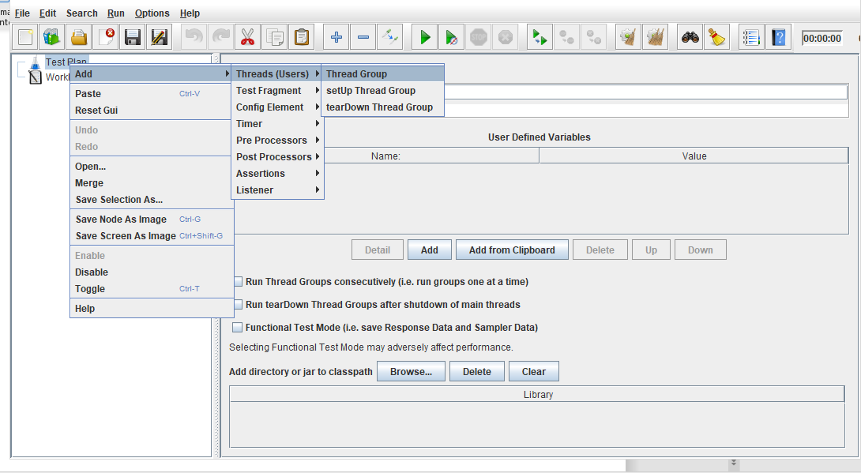

* Right click on Thread Group.
* Now, click on Add ->sampler ->SMTP sampler.

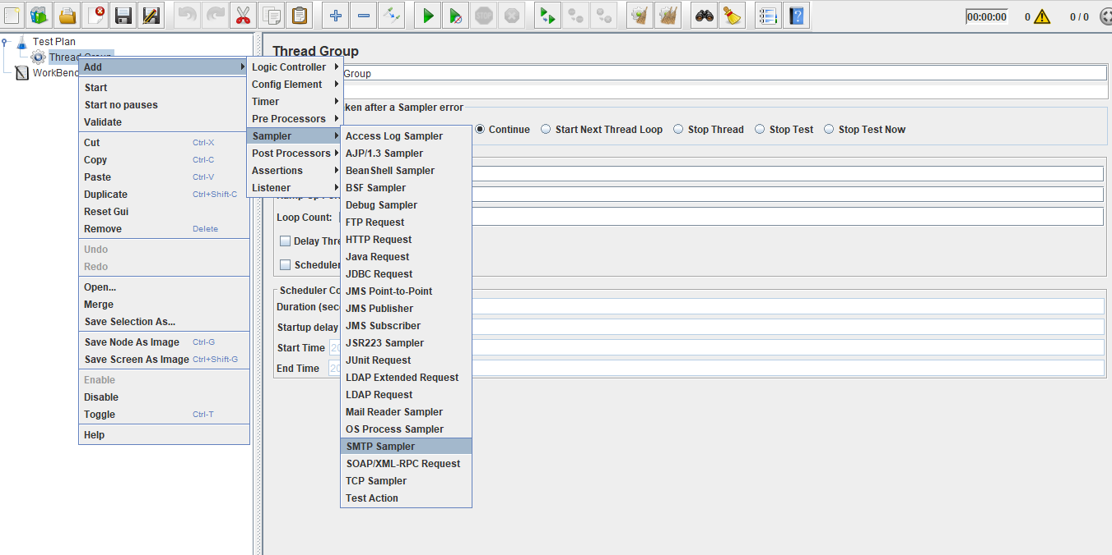

**Step 1.5.3:** Adding data in the SMTP sampler

* **Server**: smtp.googleemail.com (or) smtp.gmail.com
* **Port**: The default ports given are: 587, 25, or 465.
* **Email Address:** We can use any Gmail address for this (for example: Yarramadhu.209@gmail.com).
* The google mail SMTP server requires authentication, so select the “Use Auth” box.
* **Username**: Same as the email address (for example: Yarramadhu.209@gmail.com)
* **Password**: Enter the password (The password is displayed with asterisks in the JMeter GUI but it’s stored unencrypted (as is) in the JMeter.jmx file).
* Google mail SMTP server requires StartTLS, so click on StartTLS.
* **Message settings**: Leave this area as it is or fill it out in accordance with your test scenario.
* **Subject:** You can put anything you want here, leave it blank or send it without a subject by selecting it. But for now, we will write “Hello JMeter SMTP sampler” in the subject.
* **Message:** We will need to include the message body. This section accepts plain text and JMeter variables, functions, properties, and more.
* The ThreadNum function represents the number of thread currently being executed.

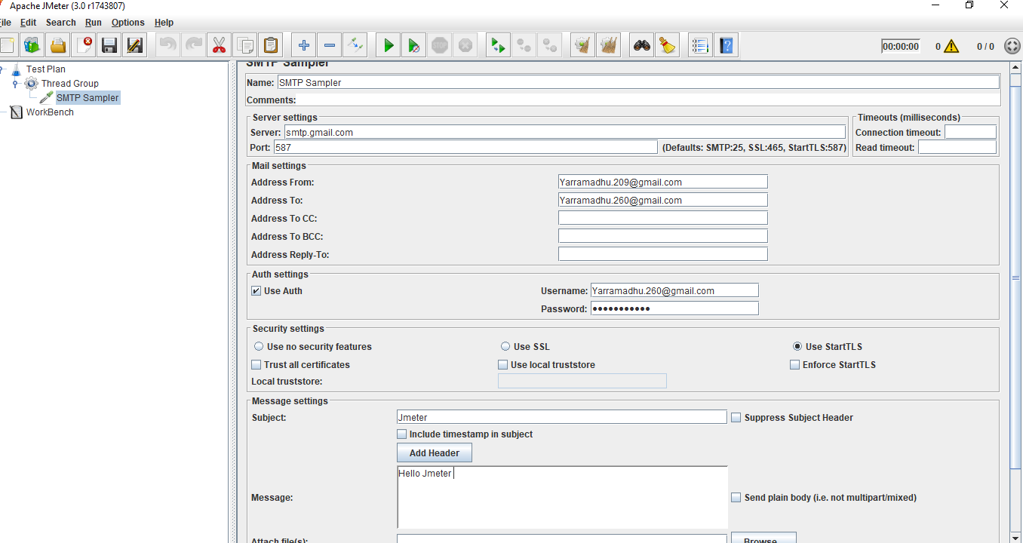

**Step 1.5.4:** Sending emails

* Click on **Run** and an email will be sent to your email address.

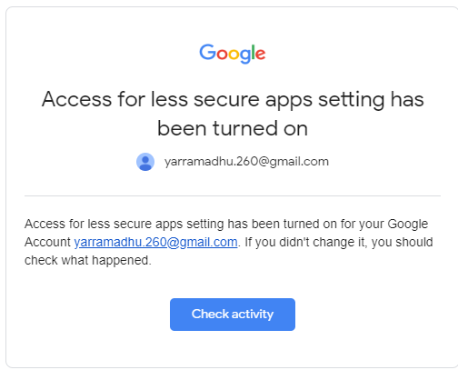

* Now, you will get an email but it will show a security alert.
* You can overcome this alert by going to Gmail settings.

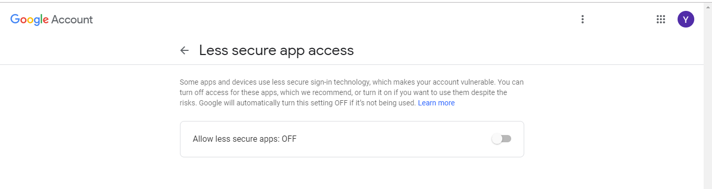

* Since the **less secure app access** is in off mode, we wouldn’t get mails.
* Therefore, you will have to turn it on.

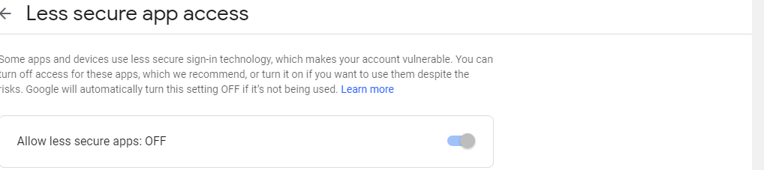

* Once its turned on, we will start getting emails.

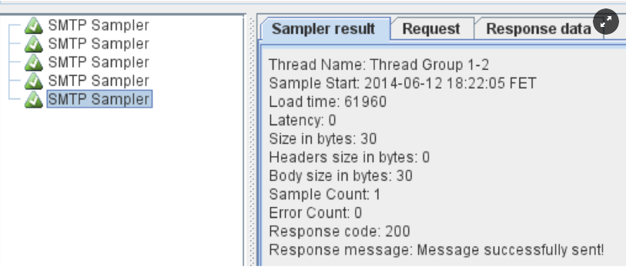

* The script will now run successfully.
* All the five emails will show up in your Gmail Web UI and the thread numbers will be displayed in the body preview.

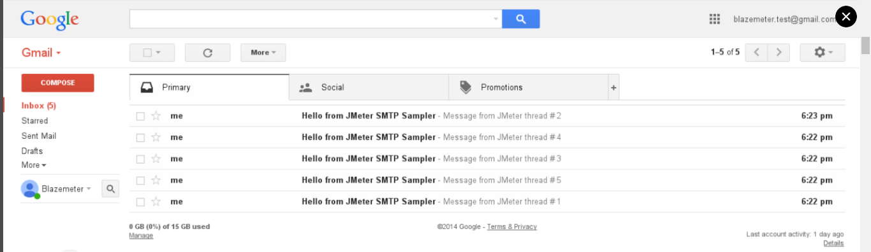

**Step 1.5.5:** Pushing the code to GitHub repositories

Open your command prompt and navigate to the folder where you have created your files.

cd <folder path>

Initialize your repository using the following command:

git init

Add all the files to your git repository using the following command:

git add . 

Commit the changes using the following command:

git commit . -m “Changes have been committed.”

Push the files to the folder you initially created using the following command:

git push -u origin master